The Wildflowers of St Peter and St Paul’s Church, Ellesborough
This display has been created to pay tribute to the tireless, custodial work of Tony Young, Ellesborough’s Churchwarden of over 25 years who recently passed away.
He was passionate about wildflowers, wildlife and gardening. He was very proud of the fact that St Peter and St Paul’s Churchyard was selected as a Local Wildlife Site (LWS) Ref. SP80107 and its wildlife value was assessed against specific criteria by the Sites Selection Panel with surveys being carried out in 2015 and 2016. The survey results, a map showing the position of this Grade 2 listed medieval church and the plant species found can be located in a digital format on the Ellesborough Church section of the Ellesborough Parish Council website. Use the following link
https://www.ellesborough-pc.gov.uk/Contents/ContentItems/44v430xzh9xq04k6wwnm3f5f5e
This ancient Churchyard is managed to protect and encourage plants and wildlife. It is left uncut until high summer to preserve and encourage wildflowers, butterflies, insects and other wildlife.
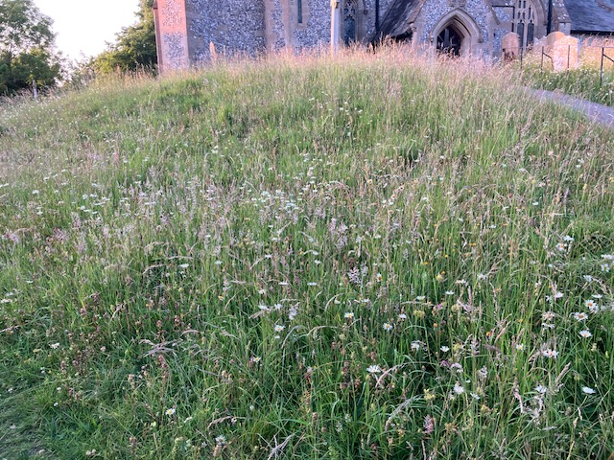
Diverse mix of wildflowers and grasses on bank south of church.
These photos have been taken during June, July and August and clearly show that wildflowers, butterflies, bees and insects have been thriving in this churchyard which is sited within a Conservation Area, in a dominant position on the escarpment of the Chilterns, in an Area of Outstanding Natural Beauty. 1
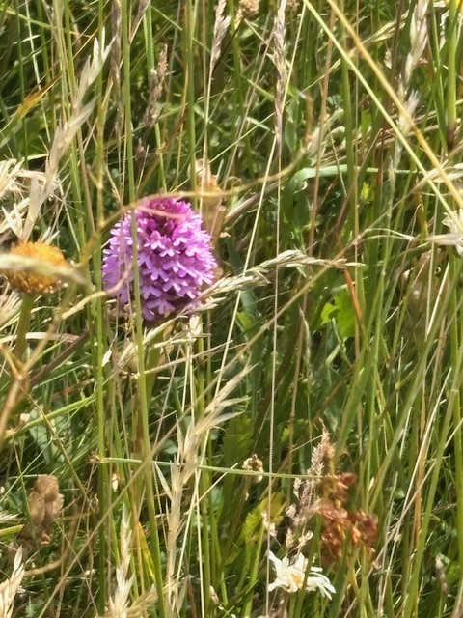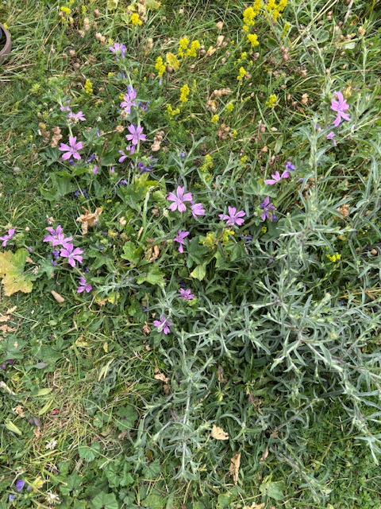
Pyramidal orchid. Common mallow.
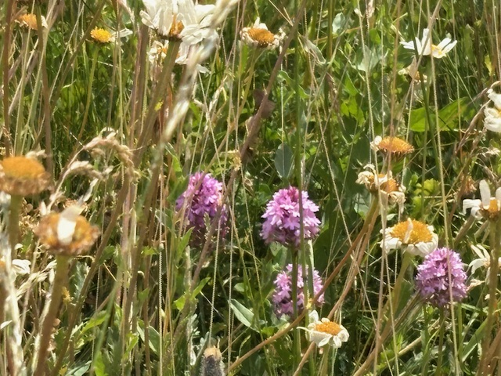
Pyramidal orchids and Ox-eye daisies.

2
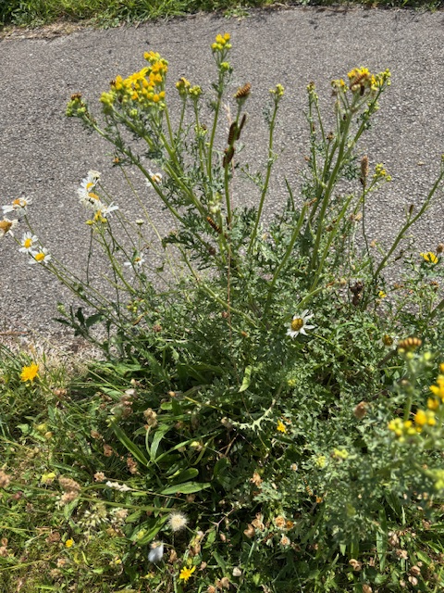
Ragwort and Ox-eye daisies.
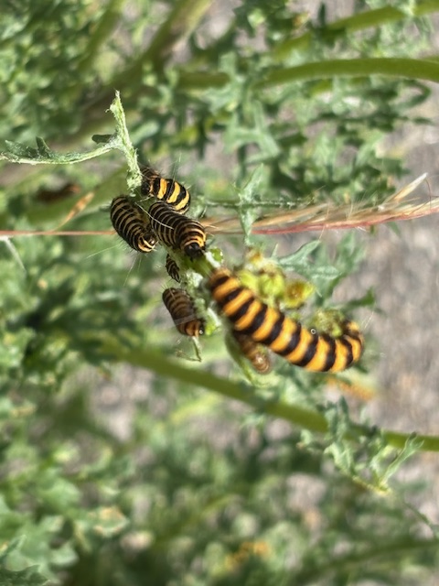
Cinnabar moth caterpillars feeding on Ragwort. 3
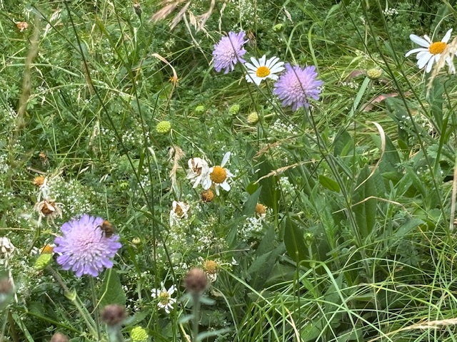
Common Carder bee feeding on Field Scabious (shown in bottom left hand corner of photo).
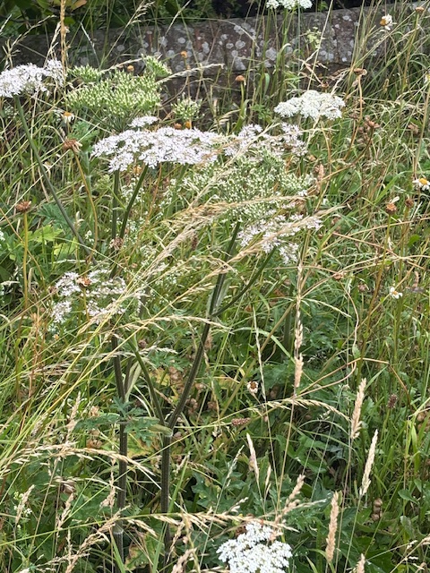
Cow parsnip and grasses. 4
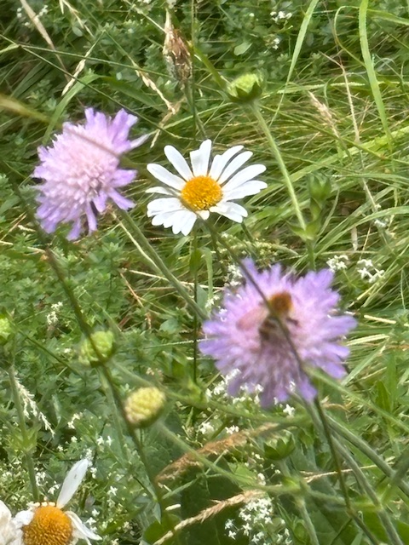
Ox-eye daisies, Field scabious and a Common Carder bee.
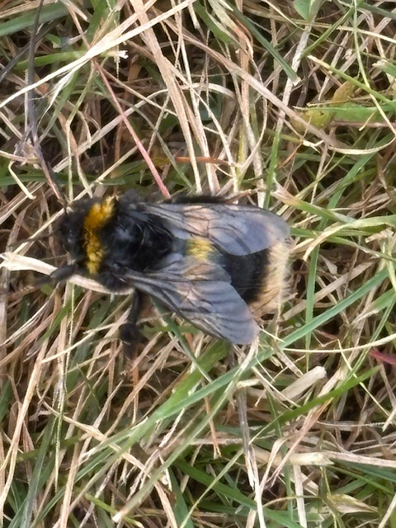
Buff-tailed bumble bee. 5
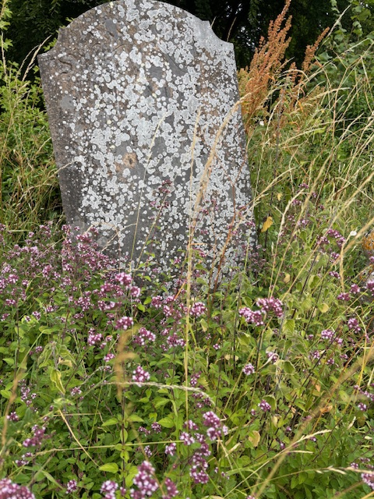
Oregano (also known as Wild Marjoram) in front of the headstone.
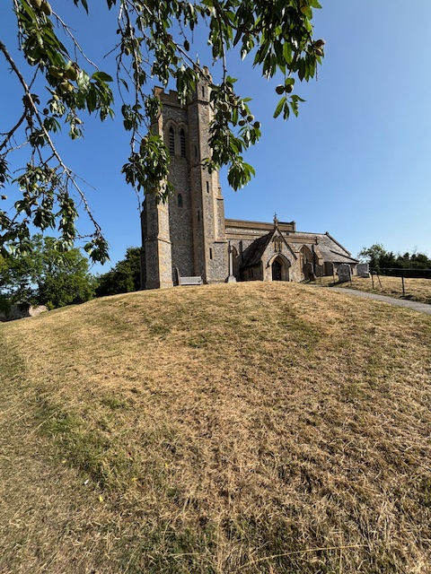
The wildflowers were monitored closely, and once the seeds in the flower heads had completely set, the wildflowers were cut the first week of August. 6
The big rake took place 2 weeks later and volunteers helped to remove the dead vegetation.
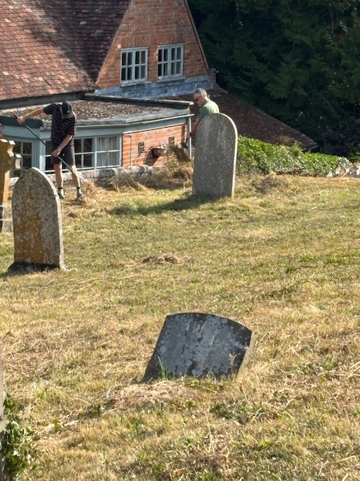
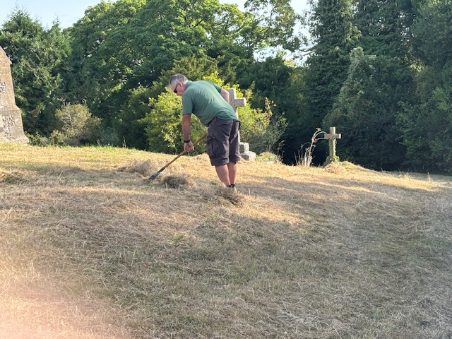
7
A second cut of the graveyard will take place in the Autumn when the hedges are also trimmed back preparing it for next year’s Spring growth.
During the middle of November some pupils from Great Kimble C of E School are going to help plant dwarf Tete-a-tete daffodil bulbs in the churchyard. They flower early spring, are scented and will provide an early pollen and nectar source for bumble bees and early emerging insects.
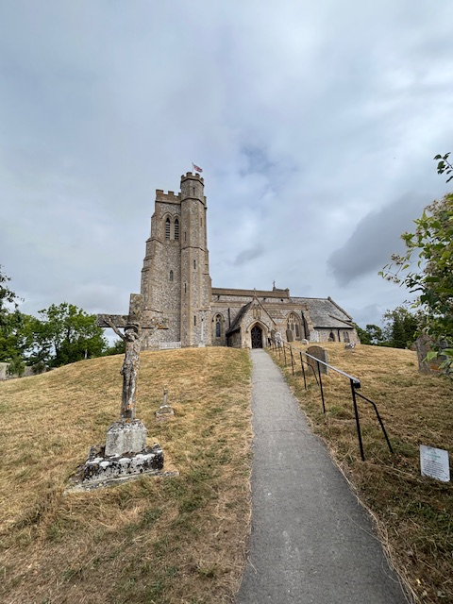
This type of daffodil have smaller stems which hopefully will get less battered by the wind and they should also provide a colourful welcome to church visitors with their golden, yellow petals. If members of the community would also like to plant some of the bulbs please contact Helen Holman helenholman@ellesborough-pc.gov.uk
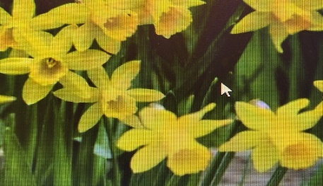
Helen Holman October 2025 8

